NAME : TASNEEM SADIKOT
PRN : 23070521162
SEM : 4 SECTION : B

Practical 07
Write and execute PL/SQL function to print /return binary equivalent of decimal number.
Introduction
A PL/SQL function is a subprogram that computes and returns a value. It helps in reusability, modular programming, and efficient database operations.
Key Concepts Used in This Program
● Functions in PL/SQL: A function must have a return type and return a value.
● Loops in PL/SQL: We use loops to repeatedly divide the decimal number by 2 to obtain its binary equivalent.
● String Operations: We build the binary number as a string.
PL/SQL Function to Convert Decimal to Binary
Steps to Convert Decimal to Binary in PL/SQL
1. Take a decimal number as input.
2. Use a LOOP to repeatedly divide the number by 2.
3. Store the remainders (0 or 1) in reverse order.
4. Return the final binary string.
PL/SQL Function Code
CREATE OR REPLACE FUNCTION decimal_to_binary(n IN NUMBER) RETURN VARCHAR2 IS
binary_result VARCHAR2(100) := ''; -- Variable to store the binary equivalent
num NUMBER := n; -- Copy of the input number remainder NUMBER; -- Stores remainder after division BEGIN
-- Check for zero case
IF num = 0 THEN
RETURN '0';
END IF;

-- Loop to convert decimal to binary
WHILE num > 0 LOOP
remainder := MOD(num, 2); -- Get remainder when divided by 2
binary_result := remainder || binary_result; -- Build binary string in reverse
num := TRUNC(num / 2); -- Reduce number by dividing by 2
END LOOP;

RETURN binary_result; -- Return final binary value END decimal_to_binary;
/
How to Execute the Function
Call the Function Using PL/SQL Block
DECLARE
decimal_num NUMBER := 10; -- Example decimal number binary_value VARCHAR2(100);
BEGIN
binary_value := decimal_to_binary(decimal_num); DBMS_OUTPUT.PUT_LINE('Binary equivalent of ' || decimal_num || ' is: ' || binary_value);
END;
/
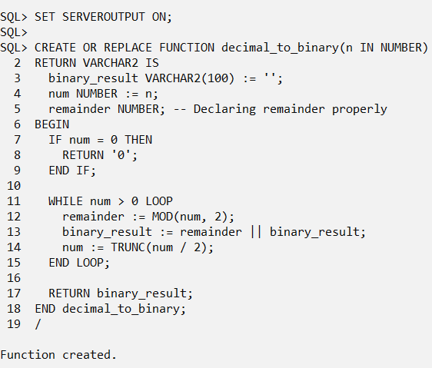
Expected Output:
Binary equivalent of 10 is: 1010 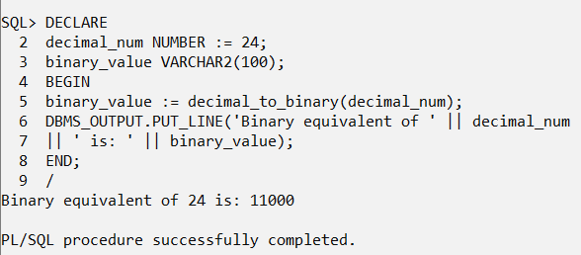
Explanation of the Code
Step | Description
Function Creation | Defines decimal_to_binary function with input n (decimal number).
Binary Result Variable | Stores the binary representation as a string.
Loop Execution | Repeatedly divides num by 2, storing remainders.

String Concatenation | Builds binary number in reverse order.
Return Statement | Returns the final binary string.

Task
1. Modify the function to display step-by-step conversion while calculating binary. 2. Write a PL/SQL block to accept user input for the decimal number and call the function.
3. Modify the function to store binary values in a table (binary_conversions).